Homework 7 STAT:3210 Experimental Design and Analysis

Yubing Li 00808366

**1. Problem 5.10:**

(a) The experiment is **2-factor factorial** designed.

|  |  |  |
| --- | --- | --- |
| Treatment factors: | Levels: | Quantitative/Qualitative |
| Glass Type (Glass) | 3 (1, 2, 3) | Qualitative |
| Temperature (Temperature) | 3 (100, 125, 150) | Quantitative |

There are **3 replicates** for each combination.

(b) 

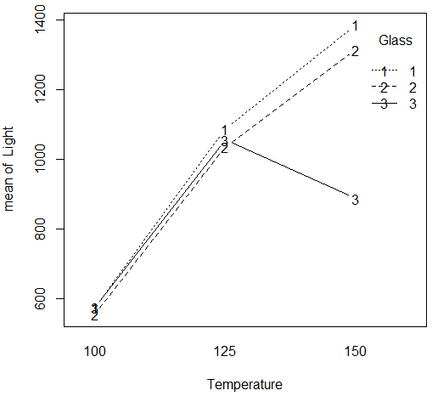

1) There’s interaction between the lines, which indicates **significant interaction effect**.

2) From the plot, we can see the **glass type 1 and highest temperature 150** will give the highest light output.

(c) **Interaction: $H_{o}: {τβ}_{11}=…={τβ}_{33}=0 vs H_{a}: {τβ}_{ij}≠0$** for at least one i, j

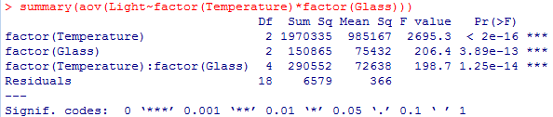

Since the p-value for the interaction term is 1.25*10^-14, which is smaller than 0.05, we **reject H0** and conclude there’s **significant interaction effect**.

(d)1) Quadratic Equation:

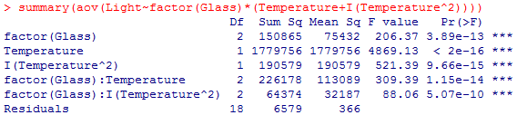

|  |  |  |  |  |
| --- | --- | --- | --- | --- |
|  | SStemp | | SSinteraction | |
| ANOVA in (c) | 1970335 (df=2) | | 290552 (df=4) | |
| ANOVA in (d) | 1779756 (df=1) | 190579 (df=1) | 226178 (df=2) | 64374 (df=2) |
| (Decomposed) | 1970335=1779756+190579 | | 290552=226178+64374 | |

Others remain the same.

2) Model Fit:

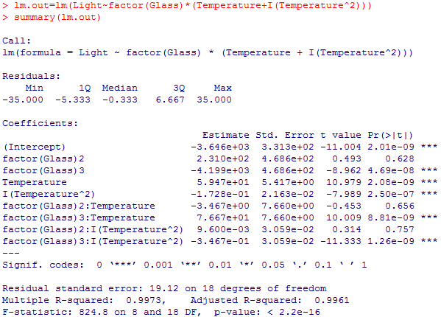

3)

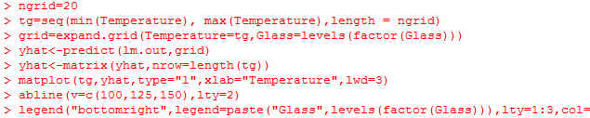

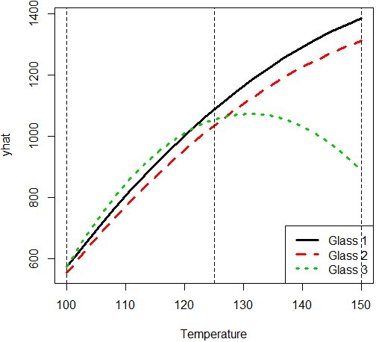

4) It’s a smoother version of the interaction plot. The **glass type 1 and highest temperature 150** will give the highest light output. It’s **consistent with** the outcome in (b).

**2. Problem 5.25:**

(a) The experiment is **2-factor factorial** designed.

|  |  |  |
| --- | --- | --- |
| Treatment factors: | Levels: | Quantitative/Qualitative |
| Polysilicon Doping (Doping) | 2 ($1×{10}^{20}, 2×{10}^{20}$) | Quantitative |
| Temperature (Temperature) | 3 (900, 950, 1000) | Quantitative |

There are **2 replicates** for each combination.

(b) (Plot on the next page)



1) Since the lines are generally parallel, there’s **no significant interaction effect**.

2) From the plot, we can see the $1×{10}^{20}$ **doping and highest temperature 1000** will give the highest current.

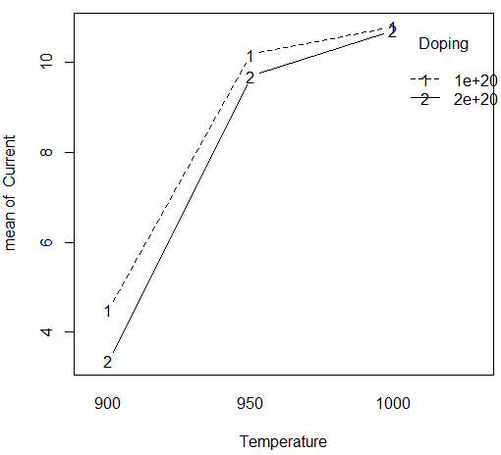

(c) **Interaction: $H_{o}: {τβ}_{11}=…={τβ}_{23}=0 vs H_{a}: {τβ}_{ij}≠0$** for at least one i, j

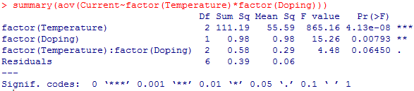

Since the p-value for the interaction term is 0.0645, which is larger than **0.05**, we **cannot reject H0** and conclude there’s **no** **significant interaction effect**.

Since the p-value for the interaction term is 0.0645, which is smaller than **0.1**, we **reject H0** and conclude there’s **significant interaction effect**.

(d)

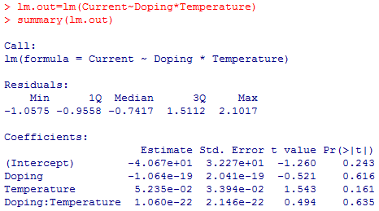

1) $\hat{y}=-40.67-1.064×{10}^{-19}\left(Doping\right)+5.235×{10}^{-2}\left(Temp\right)+1.06×{10}^{-22}\left(Doping×Temp\right)$

2) $H_{o}: β_{12}=0 vs H_{a}: β_{12}≠0$

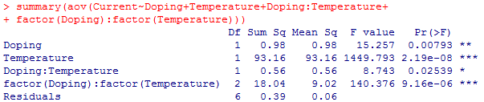

Since the p-value of factor(Doping):factor(Temperature) line is less than 0.05, we **reject the H0** and conclude **there’s lack of fit** in the reduced model.

(e)

1) SStemp=111.19 is decomposed into 93.16 and 18.03.

SStemp:doping=0.58 is decomposed into 0.56 and 0.01.

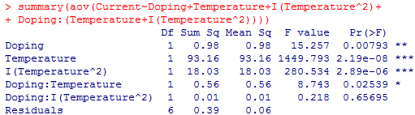

2) $\hat{y}=-899.2-6.289×{10}^{-19}\left(Doping\right)+1.863\left(Temp\right)-9.53×{10}^{-4}\left({Temp}^{2}\right)+1.208×{10}^{-21}\left(Doping×Temp\right)-5.8×{10}^{-25}\left(Doping×{Temp}^{2}\right)$

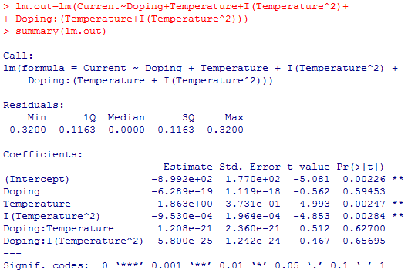

3)

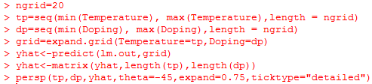

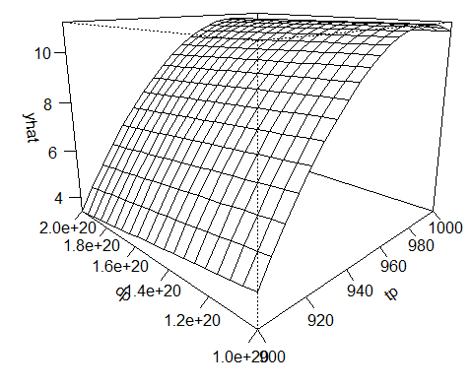

The $1×{10}^{20}$**doping and highest temperature 1000** will give the highest current. It’s **consistent with** the outcome in (b).

**3. Problem 6.5:**

(a) The experiment is **22 factorial** designed.

|  |  |  |
| --- | --- | --- |
| Treatment factors: | Levels: | Quantitative/Qualitative |
| Bit size (Bit) | 2 ($\frac{1}{16}, \frac{1}{8} in.$) | Quantitative |
| Cutting speed (Speed) | 2 (40, 90 rpm) | Quantitative |

There are **4 replicates** for each combination.

(b) **Interaction: $H_{o}: β_{12}=0 vs H_{a}: β_{12}≠0$**

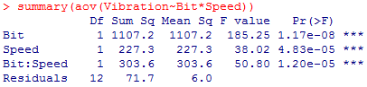

Since the p-value of interaction term is smaller than 0.05, we **reject the null hypothesis** and conclude there’s **significant interaction effect.**

(c) 

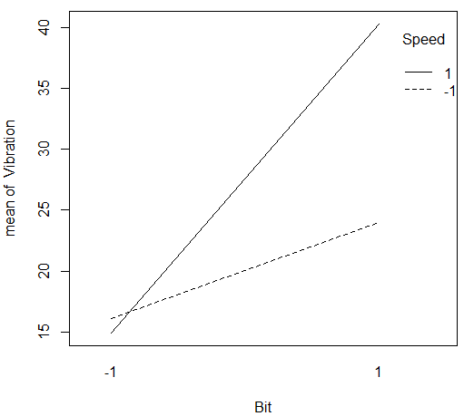

1) There’s interaction between the lines, which indicates **significant interaction effect**.

2) From the plot, we can see the **lower bit size 1/16 and lower speed 40 rpm** will give the smallest vibration. (The difference in speed is not very obvious for small vibration.)

(d) 1) Bit $=\frac{27.2+24+22.4+22.5+41+43.9+36.3+39.9}{8}-\frac{18.2+18.9+12.9+14.4+15.9+14.5+15.1+14.2}{8}$

$$=32.15-15.5125=16.638$$

Speed $=\frac{15.9+14.5+15.1+14.2+41+43.9+36.3+39.9}{8}-\frac{18.2+18.9+12.9+14.4+27.2+24+22.4+22.5}{8}$

$$=27.6-20.0625=7.5375$$

Interaction

3) The results **coincide**.

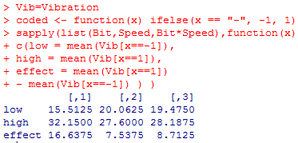

(e)

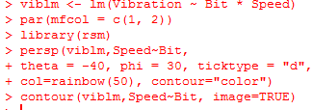

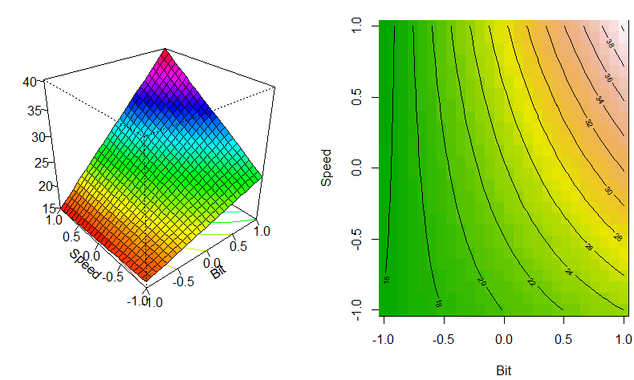

1) **There’s twist** in the response surface. That’s because the interaction term is significant.

2) The **lower bit size 1/16 and lower speed 40 rpm** (the difference in speed is not very obvious) will give the smallest vibration.

The outcome is **consistent with** (c).